COLD ASHBY VILLAGE HALL
Main Street, Cold Ashby NN6 6EL
Charity number 1024816
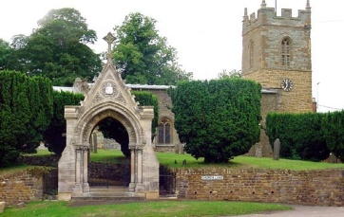
Committee Meeting

Tuesday 21st August, 2018: 7.30 p.m.

Agenda

- Minutes of meeting on 22nd May 2018
- Matters arising:
- Apologies for absence
- Chairman’s report: matters for the committee’s attention
- Finance:
- Monthly accounts May-August
- Windfarm bid
- Activities and usage update:
- Luncheon club
- Table tennis – membership extension

G Jones, Secretary August 2018

